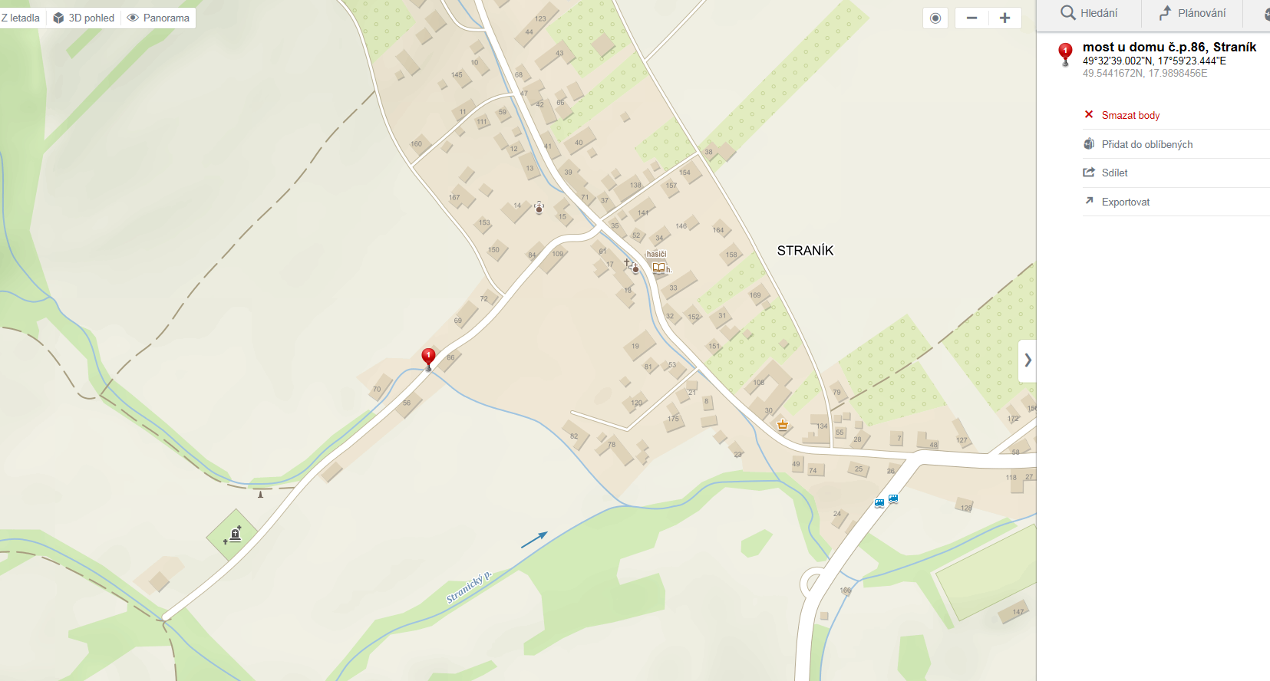

https://mapy.cz/zakladni?x=17.9899330&y=49.5442140&z=18&pano=1&pid=50749026&yaw=3.648&fov=1.257&pitch=0.301

